HVS Valve Research Network Meeting
19th of April 2025
Cairo, Egypt
Attendees: KV (Kevin Veen), DG (Donna de Geest), CV (Carlijn van der Ven), PV (Peter Verbrugghe), RR (Reda Rhellab), BA (Bardia Arabkhani), PB (Philippe Pibarot), EG (Evaldas Girdauskas), ET (Elaine Tseng), IEH (Ismail El-Hamamsy), LK (Laurent de Kerchove), Wilfried Wisser (WW)

HVS Aortic Valve Database
- Introduction

- Regulatory Update

Discussion of Decision Tree Joint Data Registry Agreement (JDRA)
KV: All current JDRA are now signed unamended. However, some JDRA’s are now coming back from Partners with proposed changes. It is stressed that changing legal documents to accommodate Partners is formally the responsibility of the Core Leaders, but that this is not always feasible. The Coordinator (Management Team) is willing to conduct JDRA questions potential partners may have on behalf of the Core Leaders, and will use the escalation structure described below to notify the appropriate groups when needed. A formal vote is called and with a unanimous decision in favour of the proposed structure.
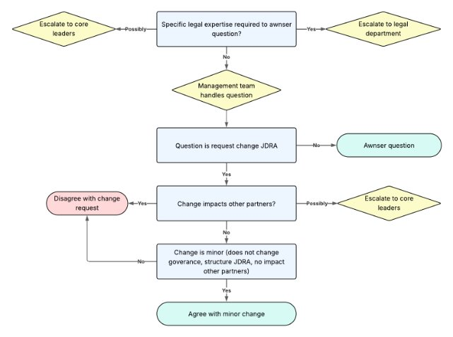
Instructions for researchers
DG: there is now a document in use that includes instructions for researchers using the data from the databases of the VRNs. This document includes practical information regarding management of data access, secure transfer of data, and requirements regarding research output. We thank the core leaders and Scientific Committee (SC) for reviewing the document. From now on, this document will be distributed amongst all researchers receiving a data extraction. To be clear: scientific output is ALL output coming from the use of data from the databases. This can be in the form of a manuscript, an abstract for a conference, poster presentation, oral presentation, etc.

- Database Progress

Transition Castor
CV: a data quality procedure has been done during the transition of the data from Telemedicine’s CleanWeb to Castor EDC. In total, 989 patients were excluded from the database. 434 of those are patients from inactive centers, which were not included in data extractions anyways. 555 patients were excluded due to reasons, such as age <18 years old or no surgery date. These patients are stored separately from the database, in case the inactive centers want to become active again or in case centers want to update the data.

Median follow-up over time
CV: follow-up has increased since the last meeting at EACTS in Lisbon. This is mainly due to exclusion of patients from inactive centers, but also because of better follow-up input from the active centers.

Follow-up completeness
CV: Total follow-up completeness is 49.08%. Follow-up completeness at 1 and 2 years is 75.71% and 70.15%, respectively. However, the goal is 85% or higher.
PB: we must increase follow-up completeness; the value of this registry is in long-term follow-up.
BA: a lot of follow-up is missing, clinical and echocardiographic.
KV: follow-up completeness is driven down by a few centers that do not update their follow-up regularly. Our focus should now be less on patient inclusion; our main focus should be on increasing follow-up.

Next goals
CV: Our goals from last year – to get our regulatory procedures in order and to do the transition from Telemedicine’s CleanWeb to Castor EDC – have now been completed. Our next goals are to enhance data quality. We are planning to do that by increasing our follow-up data, meaning we will chase centers more in the case of incomplete and low follow-up input or underreporting of certain events. In case follow-up data has increased, we will thank the centers to keep them motivated. From there we want to increase scientific output with high data quality. Moreover, we want to increase the inclusion of patients undergoing Ross procedures (now n = 293).
IEH: proposes to put the database progress in, for example, pamphlets and send these to funders in a quarterly update. This might help the databases in getting more funding. KV: agrees.
IEH: Next year, there should be a full session about the VRNs. The information shared in this room should get out of the confines of this room.
EG: every core leader should put 1 slide at the end of their presentations explaining the VRN.
KV: young HVS would like to get involved with the VRNs. This could be in the form of a SC attaché.
IEH: young HVS should get academically involved too.
ET: proposes to let researchers know which journals allow published name groups. This is in regard to all valve research network names that need to be added as co-authors to the scientific output (i.e., manuscript, abstract, etc.).

- Scientific Update

BA: gives an update on newly published projects and ongoing research projects. Since EACTS 2024, 3 articles have now been published, and we have 5 new research proposals. However, there are also multiple research proposals without any progress or who we cannot reach the PIs or coordinating investigators of. Moreover, 1 SC committee member has left, opening a spot (Lakshmi Dasi has left).
BA + PV + KV: there is currently a time limit of 6 months after data extraction, after which there should be a manuscript draft. There should also be a time limit on the acceptance of the study proposal and the receiving of data extraction. In case of no contact or no evolution in the scientific output of the study proposal, it should be passed on to the next group if this is .
ET: in case we see that some researchers are struggling due to limited resources available, we should propose them collaborating with other research groups to finish the study proposal. We should promote collaboration more.

- Finances

HVS Aortic Kids Database
- Introduction
RR: Includes all patients aged 0–18 years with aortic valve disease (AR and/or AS) and/or aortic aneurysm undergoing surgical or transcatheter treatment. Both retrospective and prospective inclusion are possible.

- Regulatory Update
RR: So far, 10 centres confirmed to participate in the HVS Aortic Kids database. Most centres are now reviewing the Joint Data Registry Agreement. 205 patients have been entered so far. The focus is not on finalizing all ethical/legal agreements and follow-up completeness of centres.

HVS Mitral Tricuspid Valve Database
- Introduction

- Database Progress
DG: So far 2208 patients have been included in the database. 2208 patients included
Batch upload by mapping data from 4 sources, and a part manually, with follow-up from 30 other hospitals in NL.

DG: In total there are numerous echo measurements (n= 5590) and Follow-up measurements (n=2848), providing rich data to conduct research.

DG: 22 Participating centres of which 9 in project 1, 16 in project 2 and 3 in project 3.

- Scientific Update

KV: Project 3 proposed by Leiden UMC Study design: Retrospective nested case-control study analysing predictors of recurrent mitral regurgitation (rMR) after successful mitral valve repair. Population: Post-surgical mitral valve repair patients with primary/degenerative disease.
Groups:
Cases: Patients with rMR during follow-up.
Controls: Matched (1:2) patients without rMR at the same follow-up time, derived from the LUMC cohort. Several matching criteria applied.

DG: First paper is in press. This is the Data Resource Profile, outlining the framework and governance of Database

- Funding

